# React Lab Report - Styling with CSS Modules

## Introduction

In this lab, I focused on applying styles to React components using CSS Modules and inline styles. I styled a dashboard for displaying cohort details with different formatting based on their status.

## Objectives and What I Learned

* Objectives:
* Understanding the need for styling React component
* Working with CSS Module and inline styles
* What I Learned:
* CSS Modules offer component-scoped styling to avoid naming conflicts.
* Inline styles can be dynamically applied based on conditions.
* Combining CSS modules with inline styles provides flexibility in styling React components.

## Hands-on Practice Summary

I styled the CohortDetails component using a CSS Module called CohortDetails.module.css. Styles were defined for layout and visual appeal. Inline styles were used to conditionally change font color based on cohort status.

## Code Snippets

### CohortDetails.module.css

.box {

  width: 300px;

  display: inline-block;

  margin: 10px;

  padding: 10px 20px;

  border: 1px solid black;

  border-radius: 10px;

}

dt {

  font-weight: 500;

}

### CohortDetails.js

import styles from './CohortDetails.module.css';

function CohortDetails(props) {

    const { cohort } = props;

    // Conditional inline style for <h3>

    const headingStyle = {

        color: cohort.currentStatus.toLowerCase() === 'ongoing' ? 'green' : 'blue'

    };

    return (

        <div className={styles.box}>

            <h3 style={headingStyle}>

                {cohort.cohortCode} - <span>{cohort.technology}</span>

            </h3>

            <dl>

                <dt>Started On</dt>

                <dd>{cohort.startDate}</dd>

                <dt>Current Status</dt>

                <dd>{cohort.currentStatus}</dd>

                <dt>Coach</dt>

                <dd>{cohort.coachName}</dd>

                <dt>Trainer</dt>

                <dd>{cohort.trainerName}</dd>

            </dl>

        </div>

    );

}

export default CohortDetails;

## Screenshot

import CohortDetails from './CohortDetails';

function App() {

  const dummyCohort = {

    cohortCode: "C123",

    technology: "React",

    startDate: "2025-07-01",

    currentStatus: "Ongoing",

    coachName: "John",

    trainerName: "Doe"

  };

  return (

    <div>

      <h2>My Cohorts</h2>

      <CohortDetails cohort={dummyCohort} />

    </div>

  );

}

export default App;

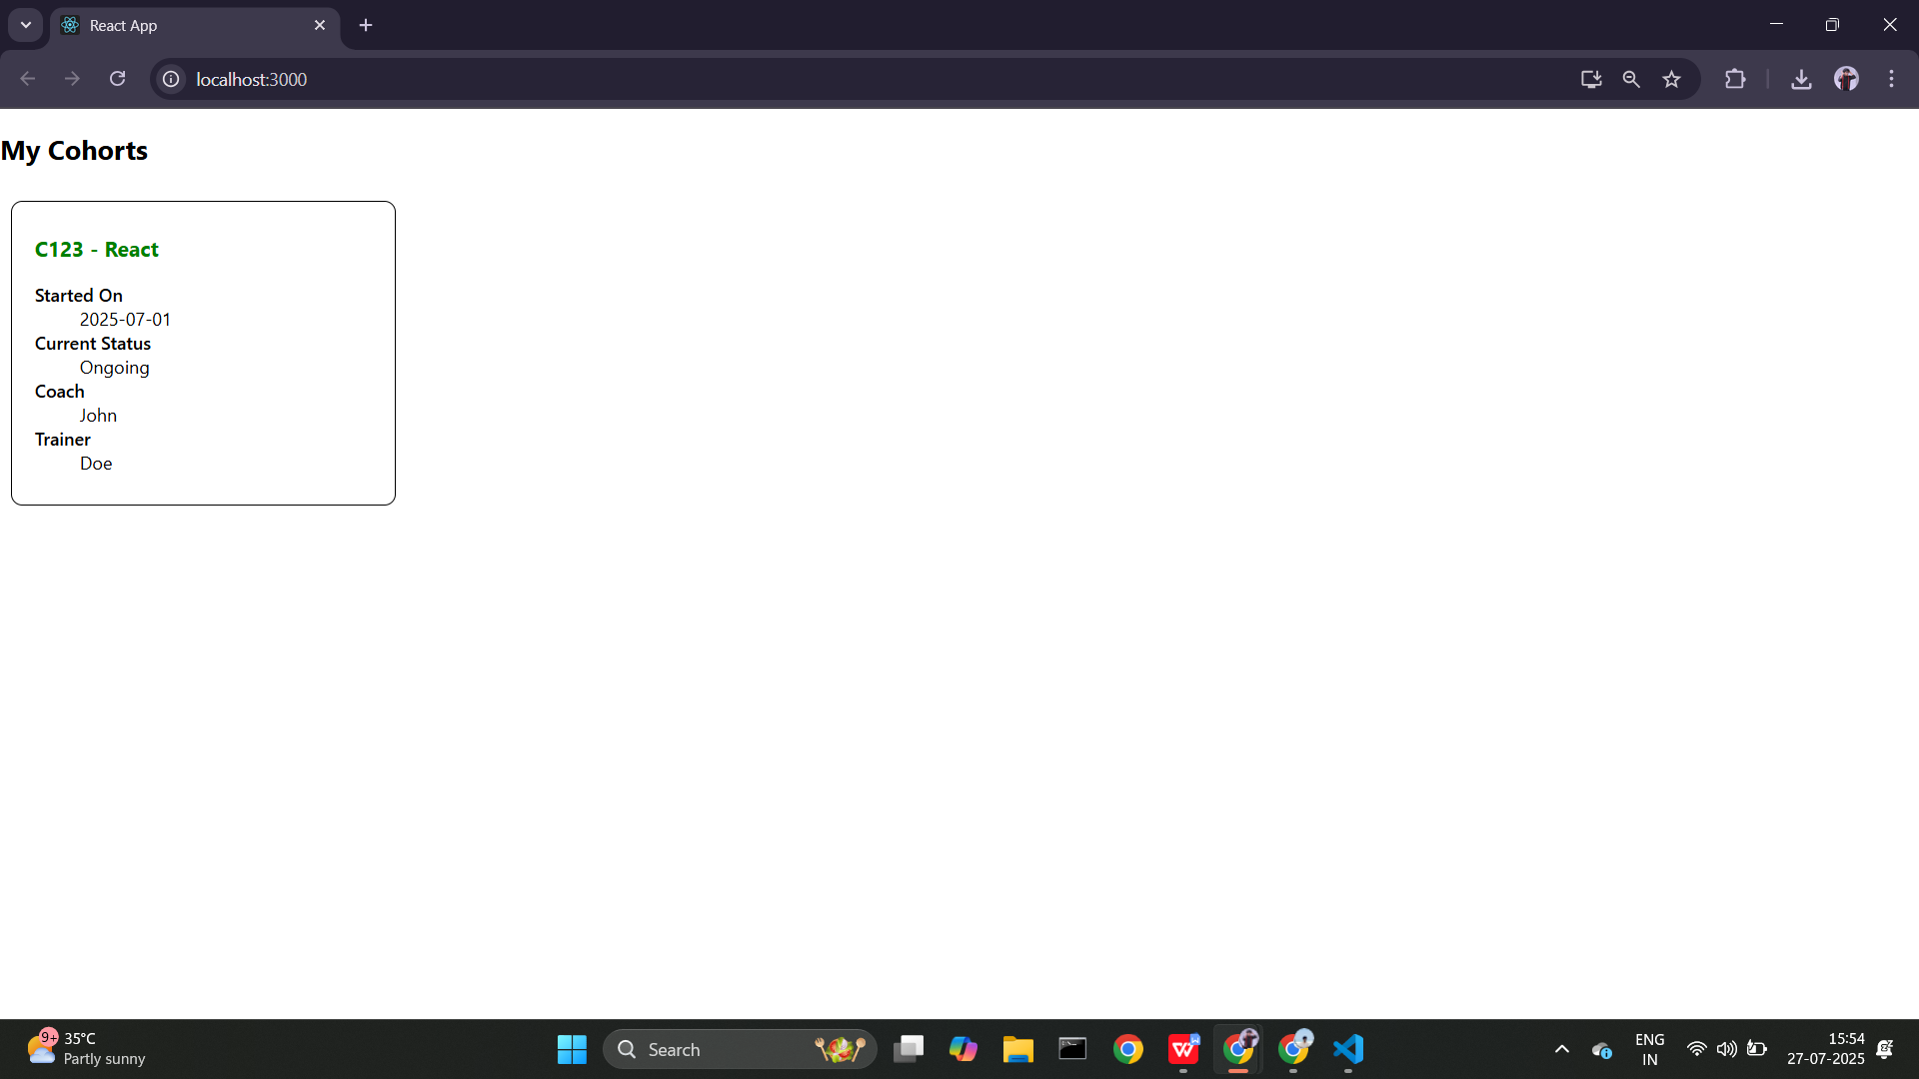

## Conclusion

This hands-on lab helped me understand styling approaches in React. I now know how to effectively use CSS Modules and conditional inline styles to enhance UI design.